Power Transformer

In Sciklit-learn We have 3 classes to perform mathematical transformation.

Box – Cox Transformation

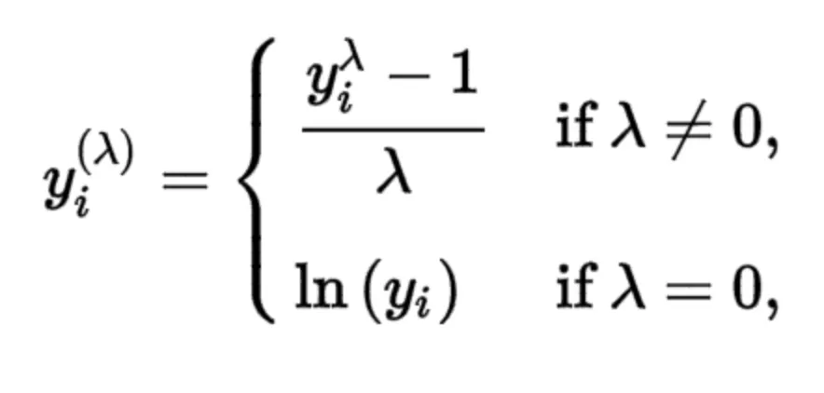

With the use of box - cox we convert given distribution to normal distribution.
It is a general transformer. Log , SQRT, and sq transformer are based on box cox transformer.

When we apply box cox transformer the highest value would be 5 and lowest would be -5.
The exponent here is a variable called lambda (A) that varies over the range of -5 to 5, and in the process of searching, we examine all values of A. Finally, we choose the optimal value (resulting in the best approximation to a normal distribution) for your variable.

Box cox is only applicable to only numbers are greater than 0.
N > 0.

It is like a drawback of Box cox. That’s why we have yoe jhonson.

Yoe Jhonson
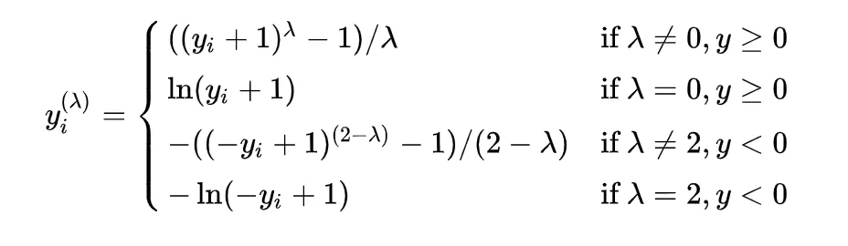

It is kind of advance variation of box cox.
The advantage of Yeo Jhonson is it works very well with negative numbers.

Both of above transformations (Box cox , and Yeo Jhonson) available in power transformation class.

